財務計量HW2

產經四 林芷瑜 s05522042

Q1.計算出apple的報酬率&時間序列圖

|  |  |
| --- | --- |
| apple return | |
| 1/02/2020 | NA |
| 1/03/2020 | -0.97696 |
| 1/06/2020 | 0.793667 |
| 1/07/2020 | -0.47141 |
| 1/08/2020 | 1.595817 |
| 1/09/2020 | 2.101847 |
| 1/10/2020 | 0.225806 |
| 1/13/2020 | 2.11394 |
| 1/14/2020 | -1.35953 |
| 1/15/2020 | -0.42947 |
| 1/16/2020 | 1.244865 |
| 1/17/2020 | 1.101023 |
| 1/21/2020 | -0.68 |
| 1/22/2020 | 0.356321 |
| 1/23/2020 | 0.480427 |
| 1/24/2020 | -0.28862 |
| 1/27/2020 | -2.98463 |
| 1/28/2020 | 2.789662 |
| 1/29/2020 | 2.071625 |
| 1/30/2020 | -0.14501 |
| 1/31/2020 | -4.53517 |
| 2/03/2020 | -0.27501 |
| 2/04/2020 | 3.248033 |
| 2/05/2020 | 0.812137 |
| 2/06/2020 | 1.162901 |
| 2/07/2020 | -1.36859 |
| 2/10/2020 | 0.473832 |
| 2/11/2020 | -0.60516 |
| 2/12/2020 | 2.347023 |
| 2/13/2020 | -0.71466 |
| 2/14/2020 | 0.024628 |
| 2/18/2020 | -1.84803 |
| 2/19/2020 | 1.437894 |
| 2/20/2020 | -1.0312 |
| 2/21/2020 | -2.28951 |
| 2/24/2020 | -4.86656 |
| 2/25/2020 | -3.44591 |
| 2/26/2020 | 1.573908 |
| 2/27/2020 | -6.76026 |
| 2/28/2020 | -0.05852 |
| 3/02/2020 | 8.901829 |
| 3/03/2020 | -3.22745 |
| 3/04/2020 | 4.534097 |
| 3/05/2020 | -3.29748 |
| 3/06/2020 | -1.3369 |
| 3/09/2020 | -8.23953 |
| 3/10/2020 | 6.954617 |
| 3/11/2020 | -3.53479 |
| 3/12/2020 | -10.3978 |
| 3/13/2020 | 11.31575 |
| 3/16/2020 | -13.7708 |
| 3/17/2020 | 4.303085 |
| 3/18/2020 | -2.47846 |
| 3/19/2020 | -0.76916 |
| 3/20/2020 | -6.55903 |
| 3/23/2020 | -2.14731 |
| 3/24/2020 | 9.560599 |
| 3/25/2020 | -0.5524 |
| 3/26/2020 | 5.128519 |
| 3/27/2020 | -4.22838 |
| 3/30/2020 | 2.813838 |
| 3/31/2020 | -0.20428 |
| 4/01/2020 | -5.40519 |
| 4/02/2020 | 1.654901 |
| 4/03/2020 | -1.44757 |
| 4/06/2020 | 8.364005 |
| 4/07/2020 | -1.16499 |
| 4/08/2020 | 2.527262 |
| 4/09/2020 | 0.719015 |
| 4/13/2020 | 1.943753 |
| 4/14/2020 | 4.926922 |
| 4/15/2020 | -0.91692 |
| 4/16/2020 | 0.791434 |
| 4/17/2020 | -1.36616 |
| 4/20/2020 | -2.09752 |
| 4/21/2020 | -3.13982 |
| 4/22/2020 | 2.839651 |
| 4/23/2020 | -0.38829 |
| 4/24/2020 | 2.846075 |
| 4/27/2020 | 0.070655 |
| 4/28/2020 | -1.63423 |
| 4/29/2020 | 3.23174 |
| 4/30/2020 | 2.087664 |
| 5/01/2020 | -1.62304 |
| 5/04/2020 | 1.404963 |
| 5/05/2020 | 1.489735 |
| 5/06/2020 | 1.026437 |
| 5/07/2020 | 1.029176 |
| 5/08/2020 | 2.352289 |
| 5/11/2020 | 1.561284 |
| 5/12/2020 | -1.1494 |
| 5/13/2020 | -1.21476 |
| 5/14/2020 | 0.61246 |
| 5/15/2020 | -0.59296 |
| 5/18/2020 | 2.328787 |
| 5/19/2020 | -0.57952 |
| 5/20/2020 | 1.926146 |

時間序列圖:

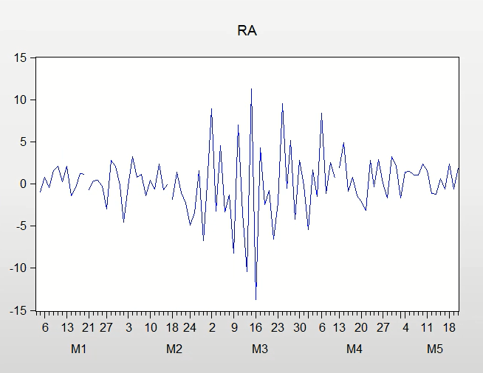

Q2.配AR模型消除自我相關

設置殘差前

dotara = apple報酬率變動=當期報酬率-前一期的報酬率

ra = apple當期報酬率（亂設讓模型不準）

|  |  |  |  |  |
| --- | --- | --- | --- | --- |
| Dependent Variable: DOTARA | | |  |  |
| Method: Least Squares | | |  |  |
| Date: 05/24/20 Time: 23:35 | | |  |  |
| Sample (adjusted): 1/03/2020 5/19/2020 | | | |  |
| Included observations: 95 after adjustments | | | |  |
|  |  |  |  |  |
|  |  |  |  |  |
| Variable | Coefficient | Std. Error | t-Statistic | Prob. |
|  |  |  |  |  |
|  |  |  |  |  |
| RA | -1.384513 | 0.095827 | -14.44808 | 0.0000 |
| C | 0.098729 | 0.353017 | 0.279672 | 0.7804 |
|  |  |  |  |  |
|  |  |  |  |  |
| R-squared | 0.691795 | Mean dependent var | | 0.030559 |
| Adjusted R-squared | 0.688481 | S.D. dependent var | | 6.164195 |
| S.E. of regression | 3.440478 | Akaike info criterion | | 5.329926 |
| Sum squared resid | 1100.831 | Schwarz criterion | | 5.383692 |
| Log likelihood | -251.1715 | Hannan-Quinn criter. | | 5.351651 |
| F-statistic | 208.7470 | Durbin-Watson stat | | 1.983640 |
| Prob(F-statistic) | 0.000000 |  |  |  |
|  |  |  |  |  |
|  |  |  |  |  |

設置殘差後:

|  |  |  |  |  |
| --- | --- | --- | --- | --- |
| Breusch-Godfrey Serial Correlation LM Test: | | | |  |
|  |  |  |  |  |
|  |  |  |  |  |
| F-statistic | 2.030518 | Prob. F(10,83) | | 0.0401 |
| Obs*R-squared | 18.67275 | Prob. Chi-Square(10) | | 0.0446 |
|  |  |  |  |  |
|  |  |  |  |  |
|  |  |  |  |  |
| Test Equation: | |  |  |  |
| Dependent Variable: RESID | | |  |  |
| Method: Least Squares | | |  |  |
| Date: 05/24/20 Time: 22:57 | | |  |  |
| Sample: 1/03/2020 5/19/2020 | | |  |  |
| Included observations: 95 | | |  |  |
| Presample missing value lagged residuals set to zero. | | | | |
|  |  |  |  |  |
|  |  |  |  |  |
| Variable | Coefficient | Std. Error | t-Statistic | Prob. |
|  |  |  |  |  |
|  |  |  |  |  |
| RA | -0.409268 | 2.881450 | -0.142036 | 0.8874 |
| C | 0.035258 | 0.381600 | 0.092395 | 0.9266 |
| RESID(-1) | 0.582234 | 2.884155 | 0.201873 | 0.8405 |
| RESID(-2) | -0.219428 | 1.113218 | -0.197112 | 0.8442 |
| RESID(-3) | 0.179733 | 0.437944 | 0.410401 | 0.6826 |
| RESID(-4) | -0.113922 | 0.192189 | -0.592761 | 0.5550 |
| RESID(-5) | 0.066142 | 0.118069 | 0.560200 | 0.5769 |
| RESID(-6) | -0.125050 | 0.103016 | -1.213883 | 0.2282 |
| RESID(-7) | 0.192368 | 0.100982 | 1.904980 | 0.0602 |
| RESID(-8) | -0.256589 | 0.101996 | -2.515685 | 0.0138 |
| RESID(-9) | 0.329840 | 0.106071 | 3.109617 | 0.0026 |
| RESID(-10) | -0.100262 | 0.110572 | -0.906755 | 0.3672 |
|  |  |  |  |  |
|  |  |  |  |  |
| R-squared | 0.196555 | Mean dependent var | | -2.03E-16 |
| Adjusted R-squared | 0.090075 | S.D. dependent var | | 3.422129 |
| S.E. of regression | 3.264369 | Akaike info criterion | | 5.321605 |
| Sum squared resid | 884.4567 | Schwarz criterion | | 5.644200 |
| Log likelihood | -240.7763 | Hannan-Quinn criter. | | 5.451958 |
| F-statistic | 1.845925 | Durbin-Watson stat | | 1.985283 |
| Prob(F-statistic) | 0.058991 |  |  |  |
|  |  |  |  |  |
|  |  |  |  |  |

設到第10期以前的殘差時，聯合檢定的結果0.0401<0.5，模型成立